Assigenment 4

Question 1:
#include <stdio.h>
int main() {
int n, i;
float num[100], sum = 0.0, avg;

printf("Enter the numbers of elements: ");
scanf("%d", &n);

while (n > 100 || n < 1) {
printf("Error! number should in range of (1 to 100).\n");
printf("Enter the number again: ");
scanf("%d", &n);
}
for (i = 0; i < n; ++i) {
printf("%d. Enter number: ", i + 1);
scanf("%f", &num[i]);
sum += num[i];
}
avg = sum / n;
printf("Average = %.2f", avg);
return 0;
}
Output:

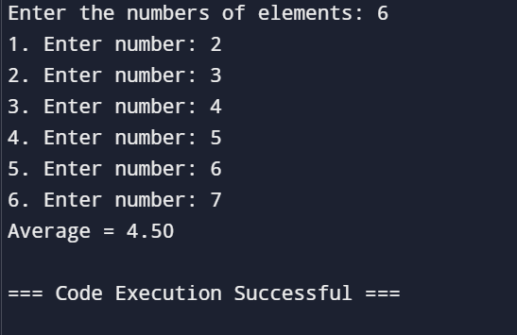

Question 2:
#include <stdio.h>

int main() {
int marks[10][3];
int i, j;
int sum;
float average;
int min_index;
int subjects_above_50;
int centum_count;
for (i = 0; i < 10; i++) {
printf("Enter marks for student %d:\n", i + 1);
for (j = 0; j < 3; j++) {
scanf("%d", &marks[i][j]);
}
}

for (i = 0; i < 10; i++) {
sum = 0;
min_index = 0;
subjects_above_50 = 0;
centum_count = 0;
for (j = 0; j < 3; j++) {
sum += marks[i][j];
if (marks[i][j] < marks[i][min_index]) {
min_index = j;
}
if (marks[i][j] > 50) {
subjects_above_50++;
}
if (marks[i][j] == 100) {
centum_count++;
}
}
average = sum / 3.0;
printf("Student %d: Average = %.2f, Minimum mark index = %d, Subjects > 50 = %d, Centum = %d\n",
i + 1, average, min_index, subjects_above_50, centum_count);
}

return 0;
}
Output:
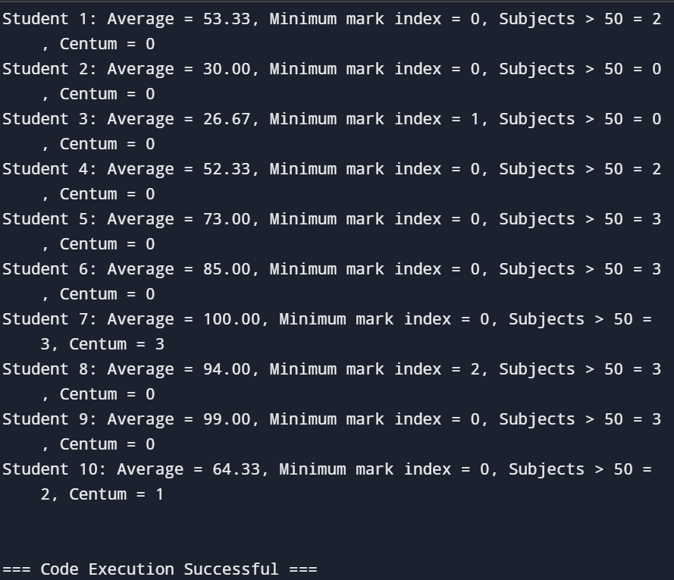

Question 3:
#include <stdio.h>

struct Employee {
int id;
char name[50];
float salary;
};

int main() {
int n;
float total_salary = 0;
float highest_salary = 0;
float lowest_salary;

printf("Enter the number of employees: ");
scanf("%d", &n);

struct Employee employees[n];

for (int i = 0; i < n; i++) {
printf("\nEnter details for employee %d:\n", i + 1);
printf("ID: ");
scanf("%d", &employees[i].id);
printf("Name: ");
scanf("%s", employees[i].name);
printf("Salary: ");
scanf("%f", &employees[i].salary);

total_salary += employees[i].salary;

if (i == 0) {
highest_salary = employees[i].salary;
lowest_salary = employees[i].salary;
} else {
if (employees[i].salary > highest_salary) {
highest_salary = employees[i].salary;
}
if (employees[i].salary < lowest_salary) {
lowest_salary = employees[i].salary;
}
}
}

float average_salary = total_salary / n;

printf("\nTotal Salary: %.2f\n", total_salary);
printf("Average Salary: %.2f\n", average_salary);
printf("Highest Salary: %.2f\n", highest_salary);
printf("Lowest Salary: %.2f\n", lowest_salary);

return 0;
}

Output:
